Report: Optimising NYC Taxi Operations

Include your visualisations, analysis, results, insights, and outcomes. Explain your methodology and approach to the tasks. Add your conclusions to the sections.

## Data Preparation

* 1. Loading the dataset
     1. **Sample the data and combine the files**

The dataset was loaded from 12 parquet files and combined into a single DataFrame. A sample of the 5% of data was extracted for efficiency in processing.

## Data Cleaning

### Fixing Columns

* + 1. **Fix the index**  
         
       I simply check for the index and it looked good, from 0 to 21
    2. **Combine the two airport_fee columns**

Airport_fee and airport_fee, two columns were appearing which I combined to handle redundancy.

### Handling Missing Values

* + 1. **Find the proportion of missing values in each column**

Using below command I got the percentage of missing values in data

* 100 * df2.isnull().mean()
  + 1. **Handling missing values in passenger_count**

Missing values in Passenger_Count handled using median.

* + 1. **Handle missing values in RatecodeID**  
       Missing values in RatecodeID were handled using **mode** which were populate maximum appearing values.
    2. **Impute NaN in congestion_surcharge**  
       I have replaced NaN values in Congestion Surcharge with median to handle null values.

**Code-** #replacing nulls with median

df2['congestion_surcharge'] = df2['congestion_surcharge'].fillna(df2['congestion_surcharge'].median())

#Printing the result

missing_values = df2['congestion_surcharge'].isnull().sum()

print(f"Missing values in 'congestion_surcharge': {missing_values}")

### Handling Outliers and Standardising Values

* + 1. **Check outliers in payment type, trip distance and tip amount columns**Outliers were checked in payment type, trip distance, and tip amount and standardised to ensure the fare consistency

## Exploratory Data Analysis

### General EDA: Finding Patterns and Trends

* + 1. **Classify variables into categorical and numerical**# Numerical columns (int and float)

**numerical_cols = df2.select_dtypes(include=['int64', 'float64']).columns.tolist()**

# Categorical columns (object and category)

**categorical_cols = df2.select_dtypes(include=['object', 'category']).columns.tolist()**

Used above commands to categorised the columns.

* + 1. **Analyse the distribution of taxi pickups by hours, days of the week, and months**

1. **Taxi pickup by hours:** During evening hours taxi pickups increases. Value is highest @6 PM.

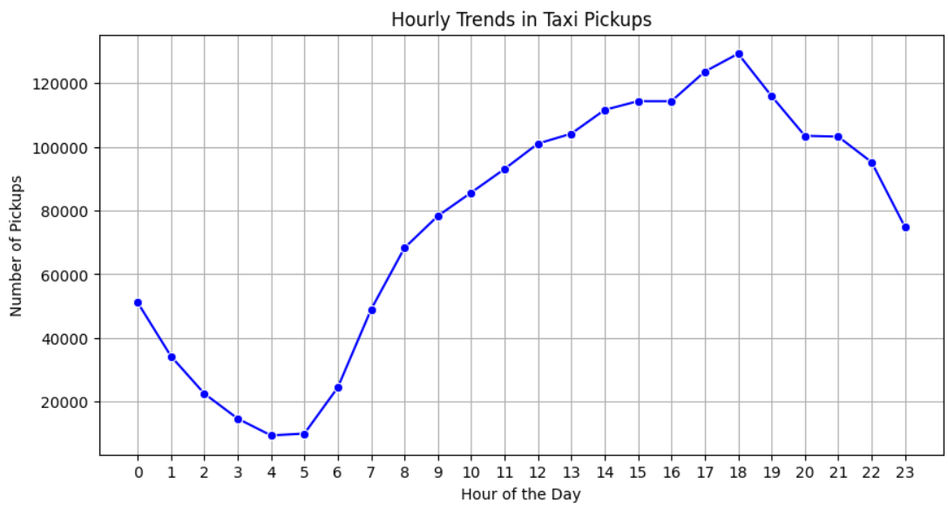

1. **Taxi pickup by Day:** During mid of the week taxi pickups increases. Value is highest on thrusday

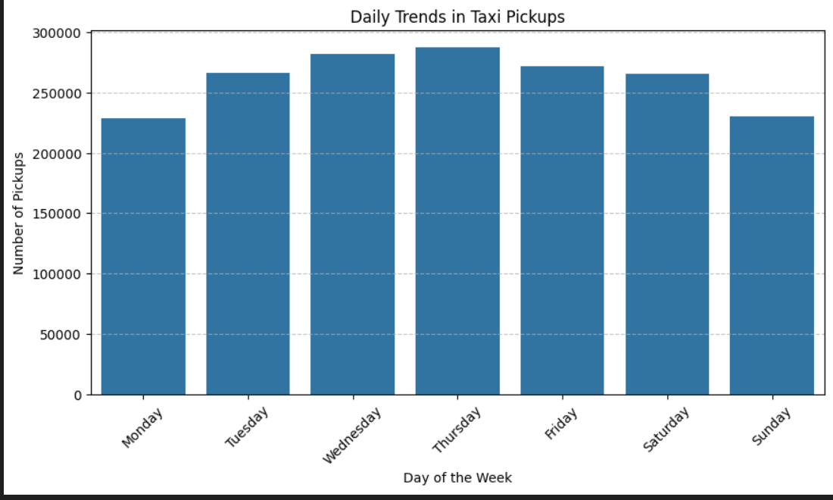

1. **Taxi pickup by Month:** Taxi pickup in quarter second and quarter four are highest.

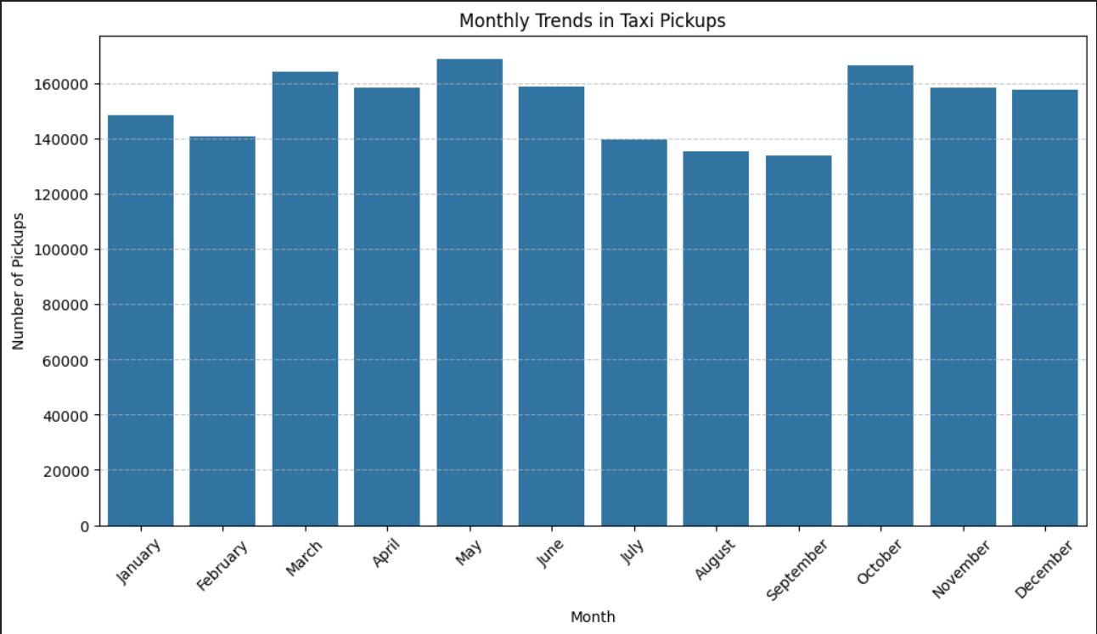

* + 1. **Filter out the zero/negative values in fares, distance and tips**columns_to_check = ['fare_amount', 'tip_amount', 'total_amount', 'trip_distance']

df2[columns_to_check].describe()

Used above code to check the negative and zero values

* + 1. **Analyse the monthly revenue trends**

Monthly revenue is highest in Oct month’23 and lowest in Feb and Aug’23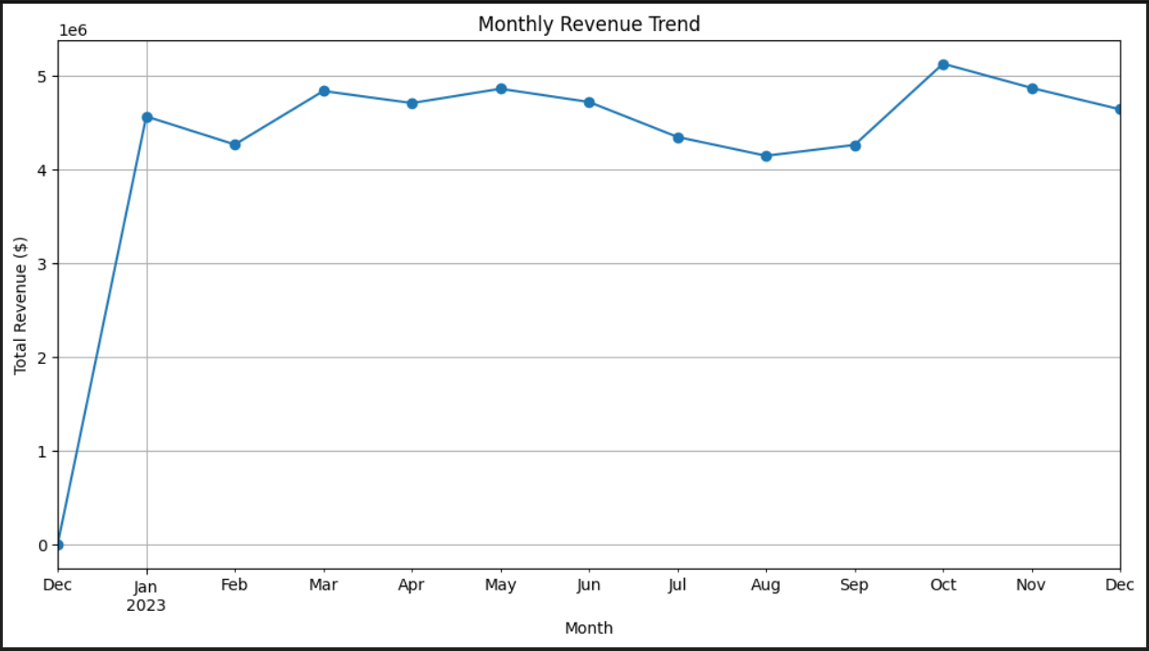

* + 1. **Find the proportion of each quarter’s revenue in the yearly revenue  
       year_quarter**

2022Q4 0.000067

2023Q1 24.694513

2023Q2 25.816265

2023Q3 23.040803

2023Q4 26.448352

**Revenue is highest in Q4**

* + 1. **Analyse and visualise the relationship between distance and fare amount**

1. A positive correlation between trip distance and fare was observed
2. Correlation between Trip Distance and Fare Amount: 0.1564

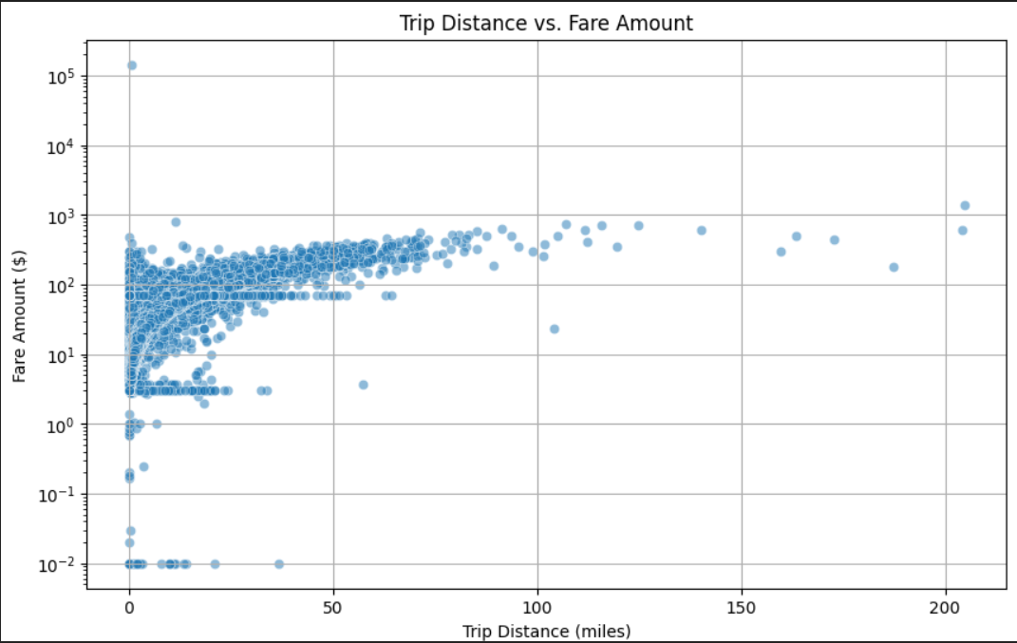

* + 1. **Analyse the relationship between fare/tips and trips/passengers**

1. Correlation is negative
2. Correlation between Trip Duration and Fare Amount: -0.0002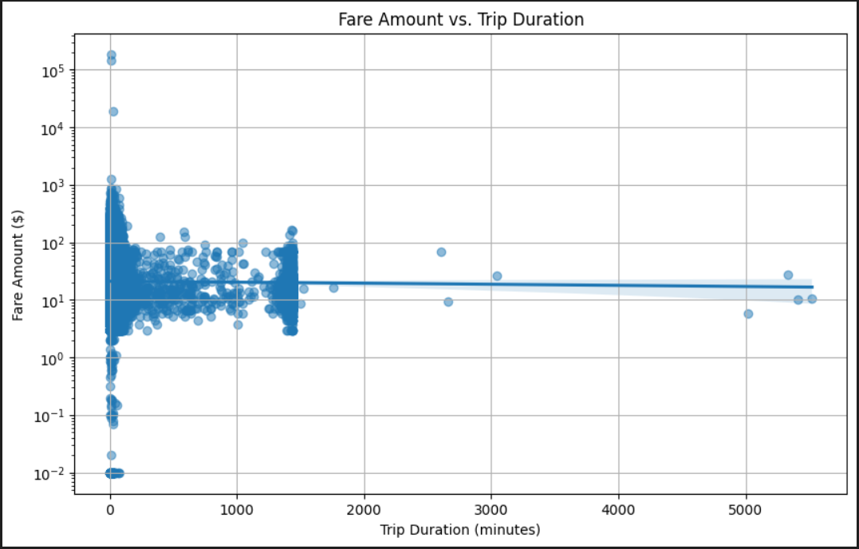
3. Correlation between Passenger Count and Fare Amount: 0.0067 and positive

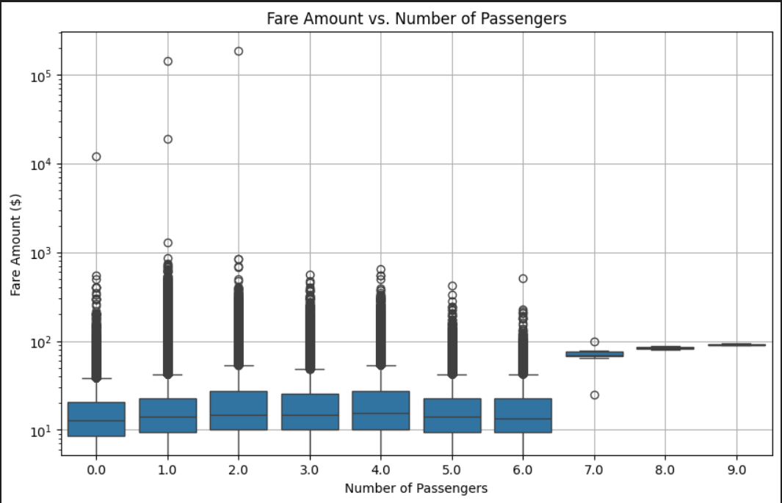

* + 1. **Analyse the distribution of different payment types**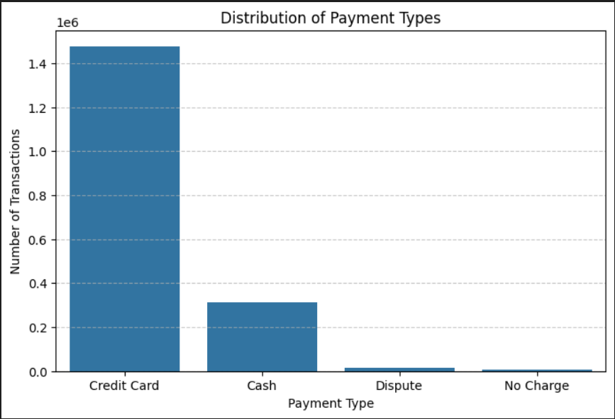
    2. **Load the taxi zones shapefile and display it**import geopandas as gpd

# Read the shapefile using geopandas

zones =gpd.read_file(r"C:\Users\Vedan\Downloads\Datasets and Dictionary-NYC\Datasets and Dictionary\taxi_zones\taxi_zones.shp")

zones.head()

* + 1. **Merge the zone data with trips data**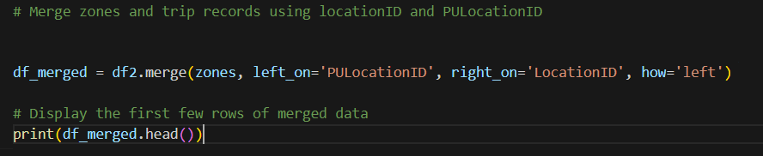
    2. **Find the number of trips for each zone/location ID**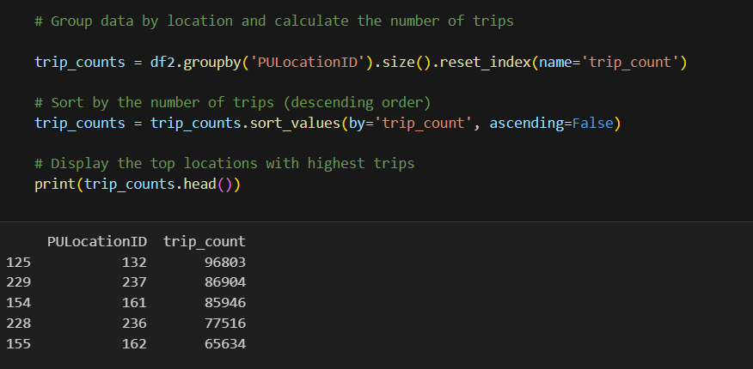
    3. **Add the number of trips for each zone to the zones dataframe  
       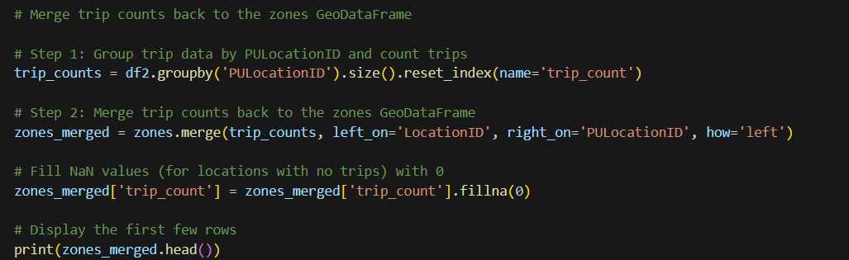**
    4. **Plot a map of the zones showing number of trips  
         
       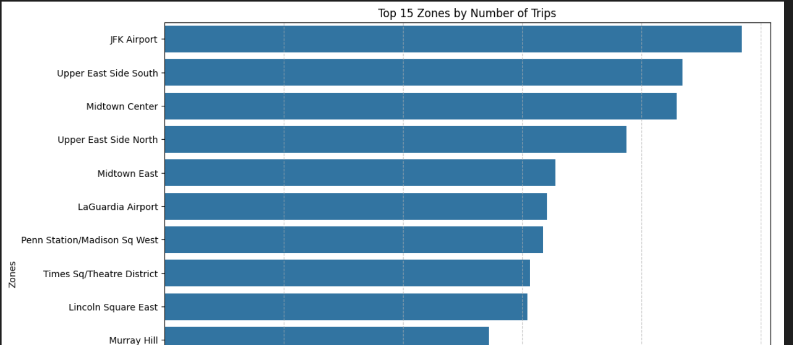**
    5. **Conclude with results**- The analysis discloses that taxi demand peaks in the evenings, mid-week, and during Q4 of the year. A positive correlation exists between distance and fare, while tip percentages vary based on factors like distance and pickup time. Optimizing taxi dispatching in high-traffic zones and adjusting pricing strategies based on peak demand can enhance operational efficiency and revenue.

### Detailed EDA: Insights and Strategies

* + 1. **Identify slow routes by comparing average speeds on different routes**

During night time on below PUlocation speed is comparatively slow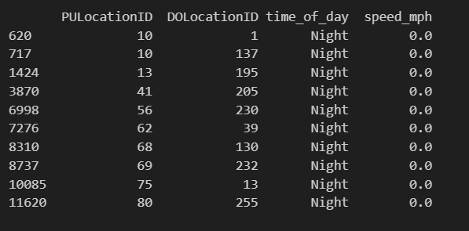

* + 1. **Calculate the hourly number of trips and identify the busy hours**6PM is the busiest hour

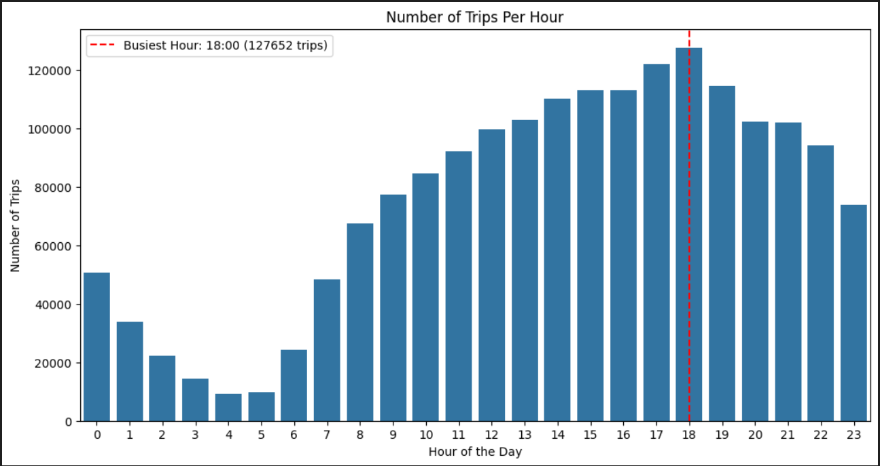

* + 1. **Scale up the number of trips from above to find the actual number of trips  
       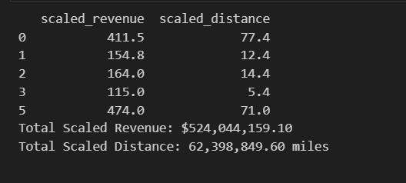**

**Code-** # Define your sampling fraction

sampling_fraction = 0.1 #Taking 10% for sampling

# Scale up the number of trips

df['scaled_revenue'] = df2['total_amount'] / sampling_fraction

df['scaled_distance'] = df2['trip_distance'] / sampling_fraction

# Display the first few rows

print(df[[ 'scaled_revenue', 'scaled_distance']].head())

# Print total scaled values

total_scaled_revenue = df['scaled_revenue'].sum()

total_scaled_distance = df['scaled_distance'].sum()

print(f"Total Scaled Revenue: ${total_scaled_revenue:,.2f}")

print(f"Total Scaled Distance: {total_scaled_distance:,.2f} miles")

* + 1. **Compare hourly traffic on weekdays and weekends**

**Code-** # Ensure datetime conversion

df['tpep_pickup_datetime'] = pd.to_datetime(df2['tpep_pickup_datetime'])

# Extract hour and day of the week

df['hour'] = df['tpep_pickup_datetime'].dt.hour

df['day_of_week'] = df['tpep_pickup_datetime'].dt.dayofweek  # Monday=0, Sunday=6

# Define weekday vs weekend

df['day_type'] = df['day_of_week'].apply(lambda x: 'Weekday' if x < 5 else 'Weekend')

# Aggregate trip counts per hour

trips_per_hour = df.groupby(['day_type', 'hour']).size().reset_index(name='trip_count')

# Plot

plt.figure(figsize=(12, 6))

sns.set_theme(style="whitegrid")

sns.lineplot(data=trips_per_hour, x='hour', y='trip_count', hue='day_type', marker="o")

# Labels and title

plt.xlabel("Hour of the Day")

plt.ylabel("Number of Trips")

plt.title("Hourly Trip Trends: Weekdays vs. Weekends")

plt.xticks(range(0, 24))

plt.legend(title="Day Type")

plt.show()

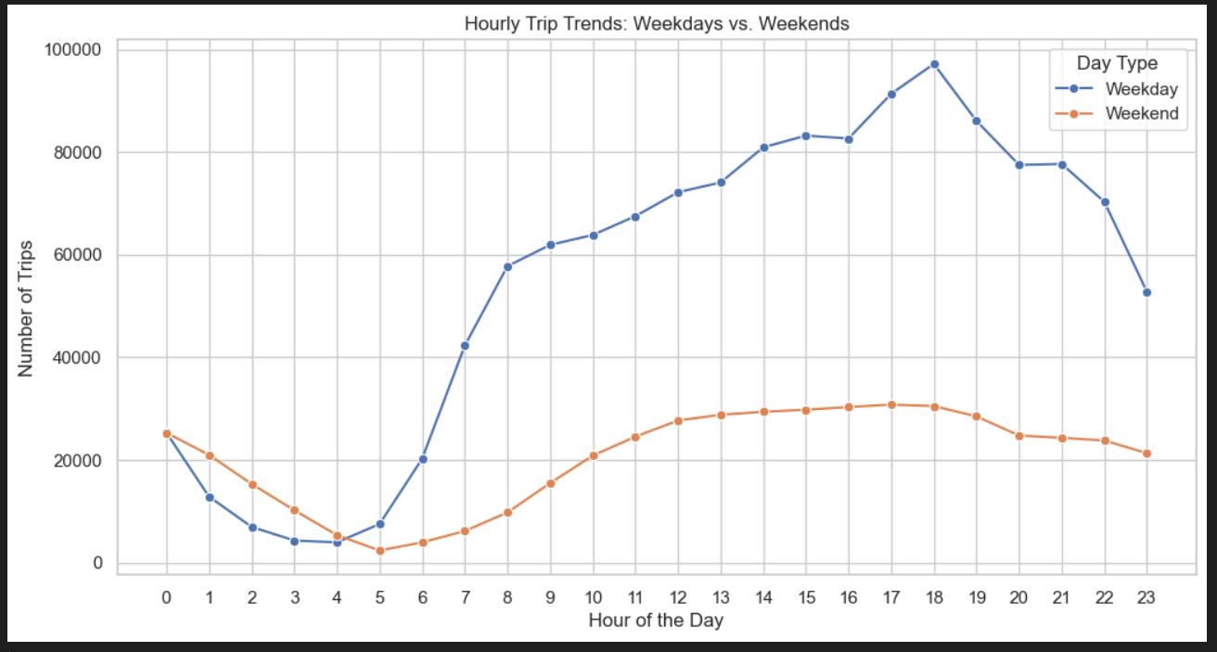

* + 1. **Identify the top 10 zones with high hourly pickups and drops**

Code- # Find top 10 pickup and dropoff zones

# Step 1: Count top 10 pickup zones

top_pickup_zones = df2['PULocationID'].value_counts().head(10).reset_index()

top_pickup_zones.columns = ['LocationID', 'trip_count']

# Step 2: Count top 10 dropoff zones

top_dropoff_zones = df2['DOLocationID'].value_counts().head(10).reset_index()

top_dropoff_zones.columns = ['LocationID', 'trip_count']

# Step 3: Merge with zone names (if available)

if 'zone' in zones.columns:  # Assuming 'zones' has a mapping of LocationID to zone names

    top_pickup_zones = top_pickup_zones.merge(zones[['LocationID', 'zone']], on='LocationID', how='left')

    top_dropoff_zones = top_dropoff_zones.merge(zones[['LocationID', 'zone']], on='LocationID', how='left')

# Step 4: Plot Top 10 Pickup Zones

plt.figure(figsize=(12, 5))

sns.barplot(x=top_pickup_zones['trip_count'], y=top_pickup_zones['zone'])

plt.xlabel("Number of Trips")

plt.ylabel("Pickup Zone")

plt.title("Top 10 Pickup Zones")

plt.show()

# Step 5: Plot Top 10 Dropoff Zones

plt.figure(figsize=(12, 5))

sns.barplot(x=top_dropoff_zones['trip_count'], y=top_dropoff_zones['zone'])

plt.xlabel("Number of Trips")

plt.ylabel("Dropoff Zone")

plt.title("Top 10 Dropoff Zones")

plt.show()

**Top 10 Pickup Zones:**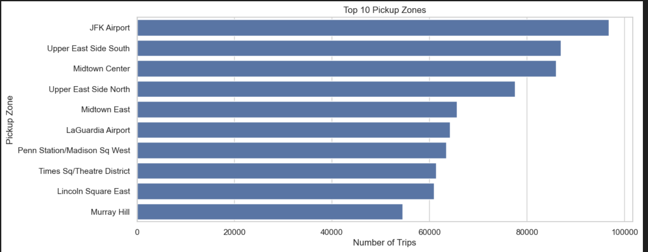

**Top 10 Dropoff Zones:**

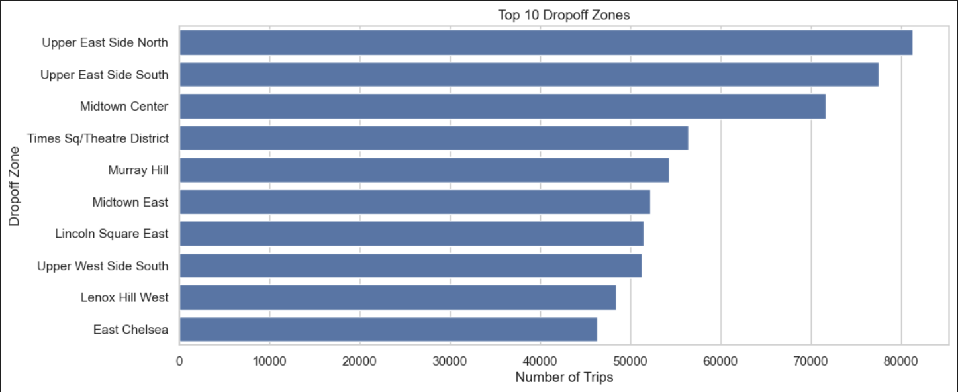

* + 1. **Find the ratio of pickups and dropoffs in each zone**

**Code:** # Find the top 10 and bottom 10 pickup/dropoff ratios

# Step 1: Count total pickups and dropoffs

pickup_counts = df2['PULocationID'].value_counts().reset_index()

pickup_counts.columns = ['LocationID', 'pickup_count']

dropoff_counts = df2['DOLocationID'].value_counts().reset_index()

dropoff_counts.columns = ['LocationID', 'dropoff_count']

# Step 2: Merge pickup and dropoff counts

zone_ratios = pickup_counts.merge(dropoff_counts, on='LocationID', how='outer').fillna(0)

# Step 3: Compute the pickup/dropoff ratio

zone_ratios['pickup_dropoff_ratio'] = zone_ratios['pickup_count'] / (zone_ratios['dropoff_count'] + 1)  # Avoid division by zero

# Step 4: Merge with zone names

if 'zone' in zones.columns:

    zone_ratios = zone_ratios.merge(zones[['LocationID', 'zone']], on='LocationID', how='left')

# Step 5: Sort and extract top/bottom 10

top_10_ratios = zone_ratios.sort_values(by='pickup_dropoff_ratio', ascending=False).head(10)

bottom_10_ratios = zone_ratios.sort_values(by='pickup_dropoff_ratio', ascending=True).head(10)

# Step 6: Plot the Top 10 Ratios

plt.figure(figsize=(12, 5))

sns.barplot(x=top_10_ratios['pickup_dropoff_ratio'], y=top_10_ratios['zone'])

plt.xlabel("Pickup/Dropoff Ratio")

plt.ylabel("Zone")

plt.title("Top 10 Pickup/Dropoff Ratios")

plt.show()

**Top 10 Pickup Ratio:**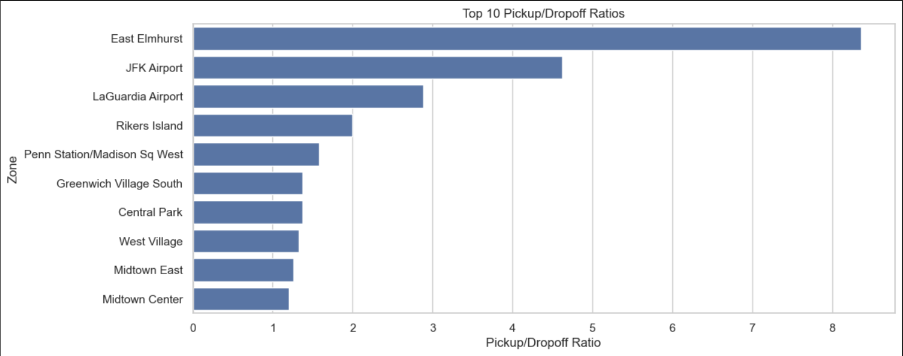

**Top 10 Dropoff Ratio:**

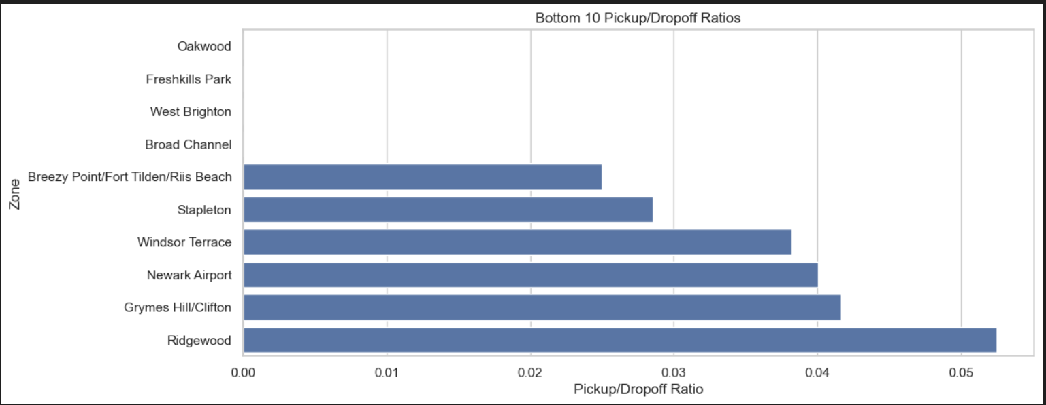

* + 1. **Identify the top zones with high traffic during night hours**
    2. **Find the revenue share for nighttime and daytime hours**
    3. **For the different passenger counts, find the average fare per mile per passenger**

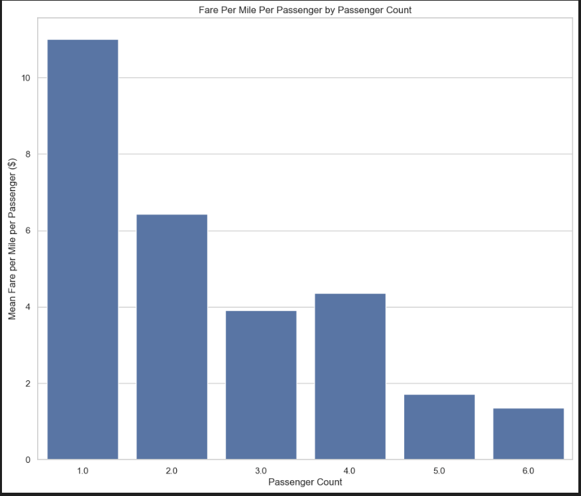

* + 1. **Find the average fare per mile by hours of the day and by days of the week**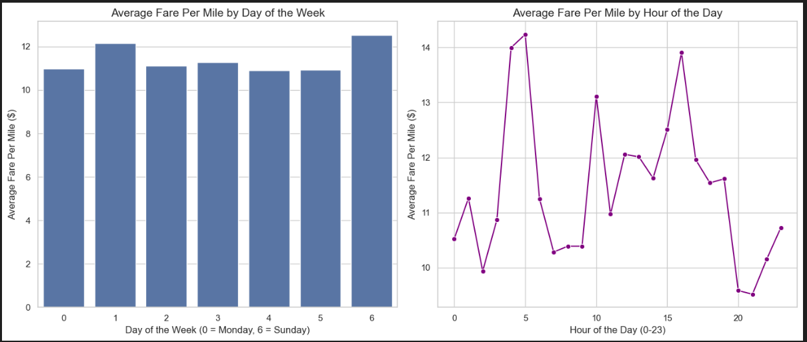
    2. **Analyse the average fare per mile for the different vendors  
         
       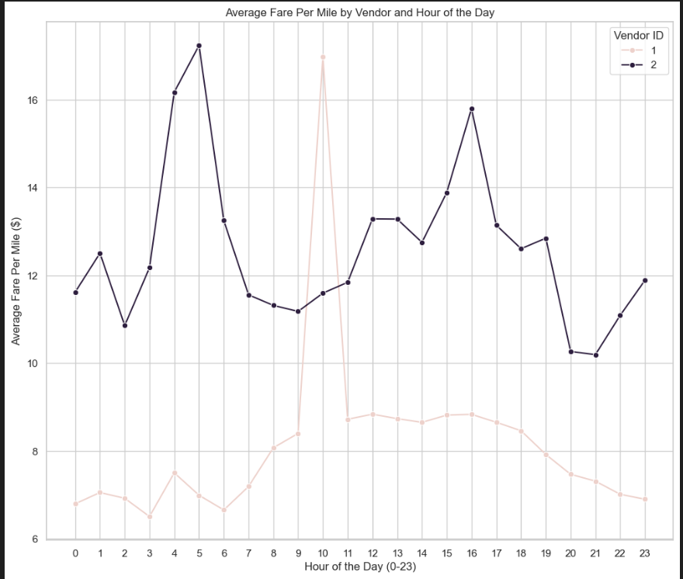**
    3. **Compare the fare rates of different vendors in a distance-tiered fashion**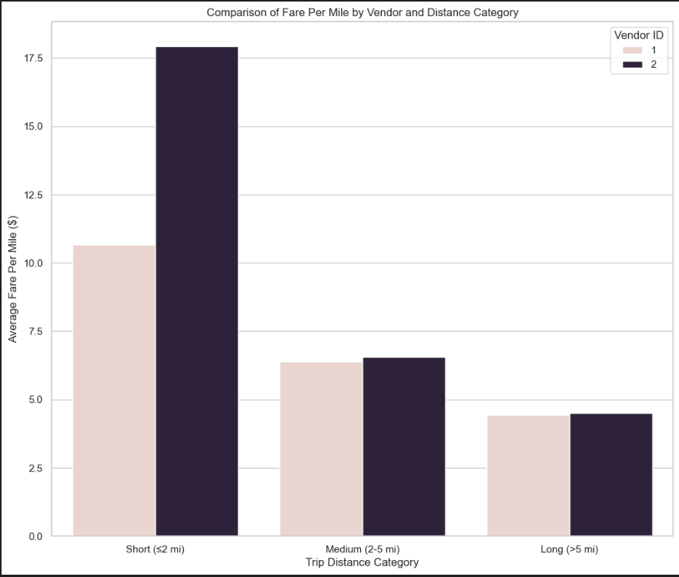
    4. **Analyse the tip percentages**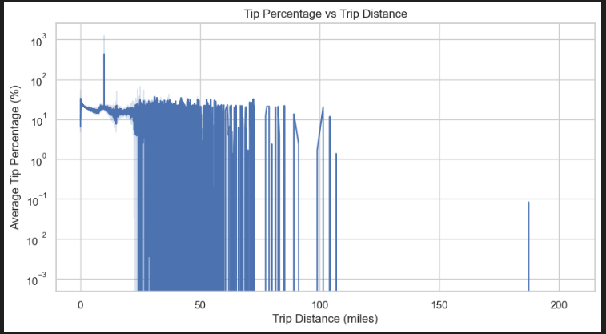
    5. 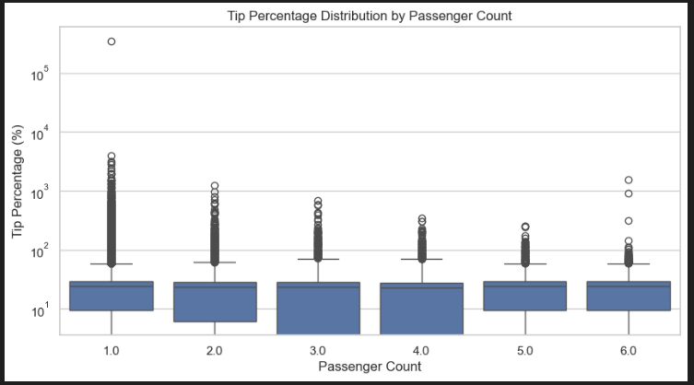

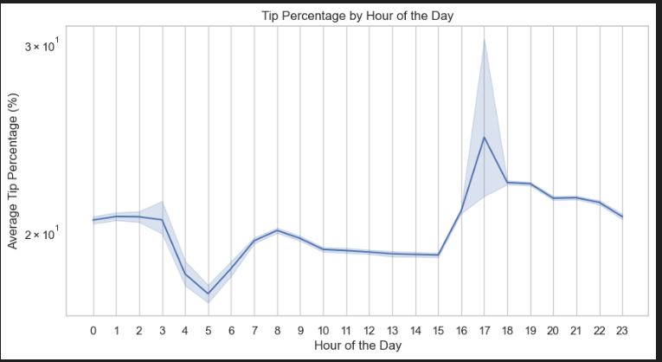

* + 1. **Analyse the trends in passenger count**

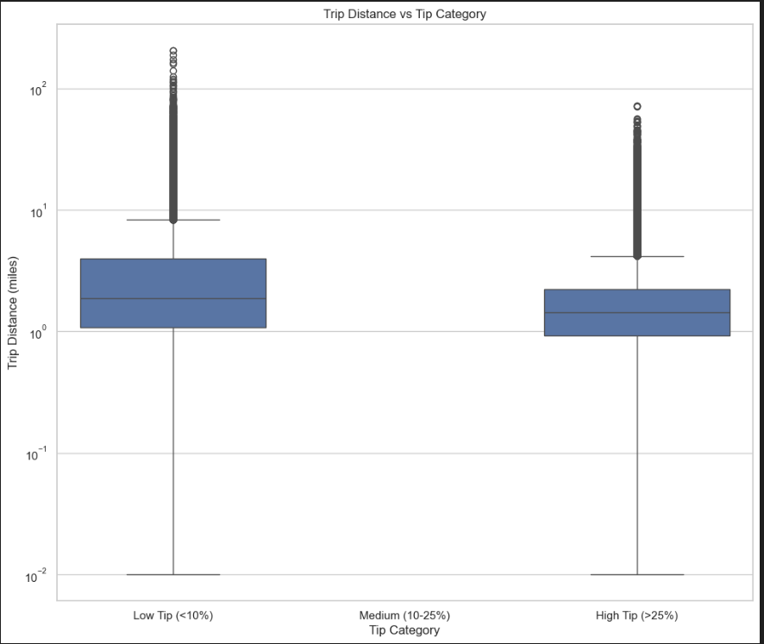

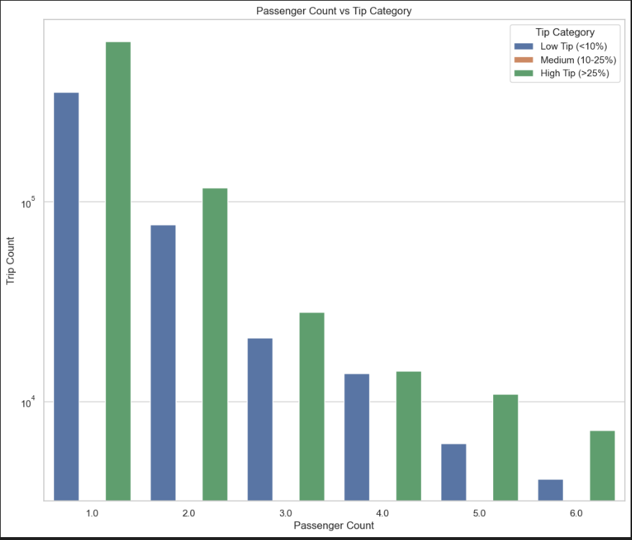

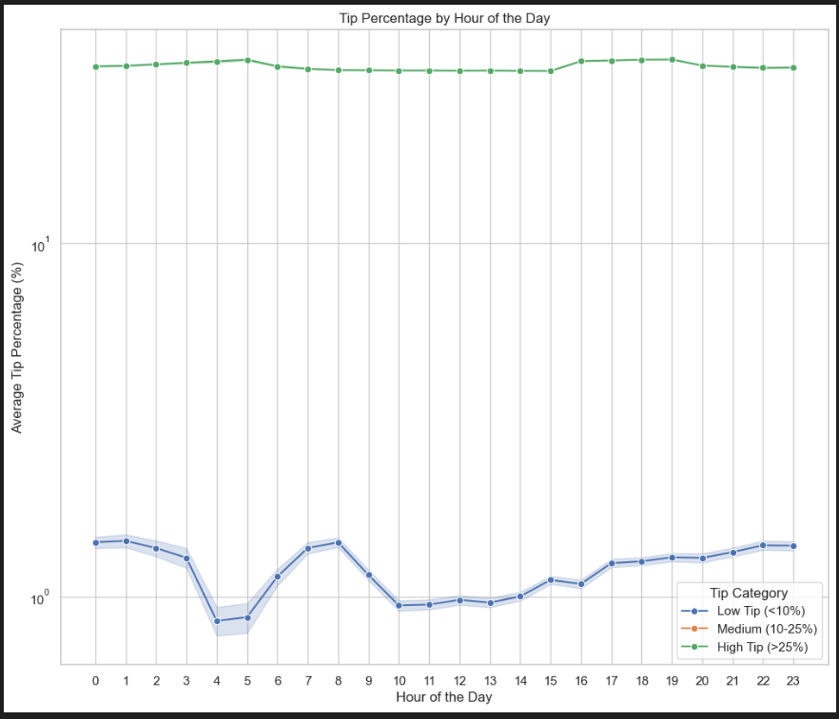

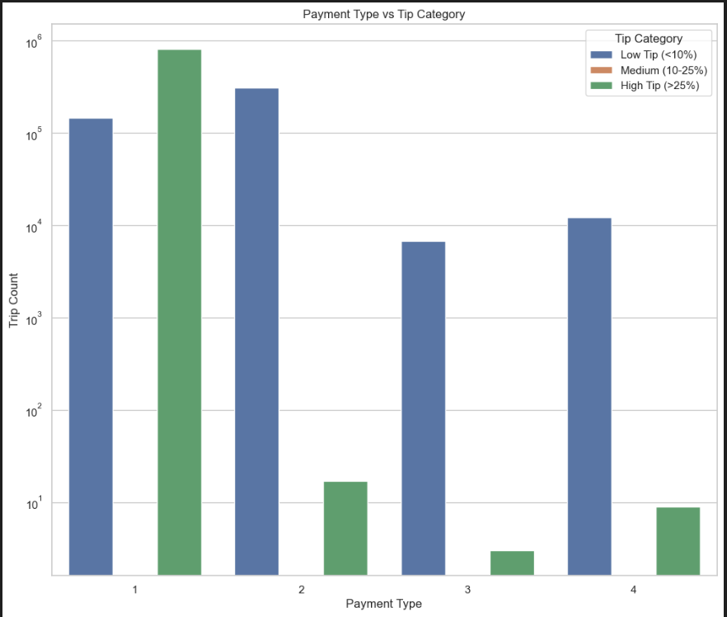

* + 1. **Analyse the variation of passenger counts across zones**

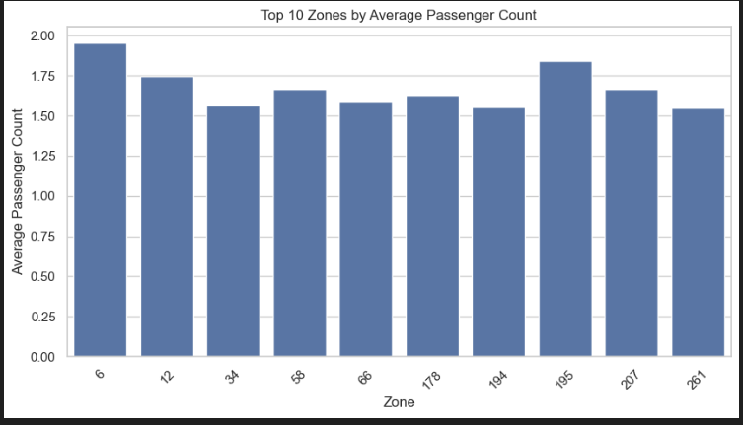

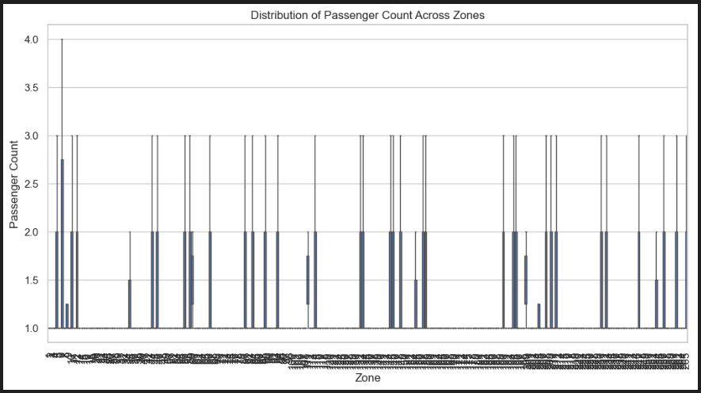

* + 1. **Analyse the pickup/dropoff zones or times when extra charges are applied more frequently.**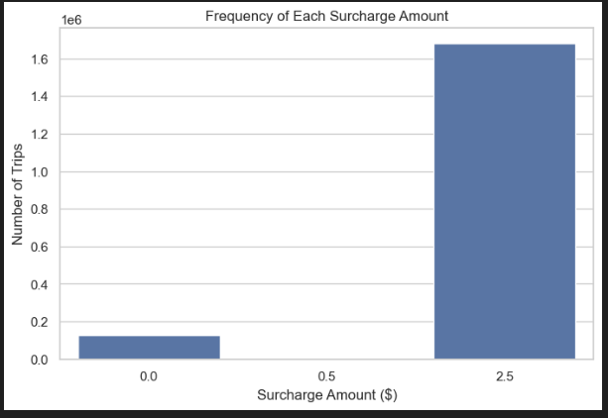

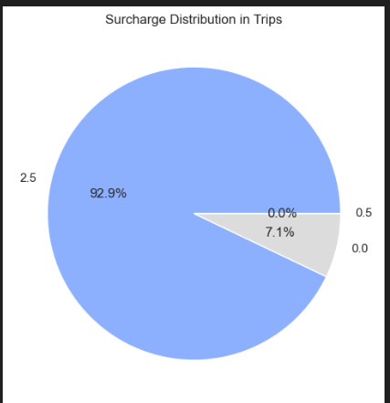

## Conclusions

### Final Insights and Recommendations

* + 1. **Recommendations to optimize routing and dispatching based on demand patterns and operational inefficiencies.**  
       - Since taxi demand peaks at **6 PM and midweek (Thursday)**, routing algorithms should prioritize these high-traffic areas for cab availability.
* Assign more taxis to **high-revenue quarters (Q2 & Q4)** and areas with high trip volumes.
* Use historical trip data to predict demand surges and dispatch cabs in advance.
  + 1. **Suggestions on strategically positioning cabs across different zones to make best use of insights uncovered by analysing trip trends across time, days and months.**
* Position cabs near the top 10 pickup zones identified in the report.
* Since nighttime has slow-moving traffic in certain zones, increase availability in well-lit and high-demand areas.
* Deploy more cabs in Q2 and Q4, as these have the highest revenue.
  + 1. **Propose data-driven adjustments to the pricing strategy to maximize revenue while maintaining competitive rates with other vendors.**
* Charge higher rates for longer trips, as there's a positive correlation between distance and fare.
* Differentiate pricing for single vs. multiple passengers to maximize per-mile revenue.